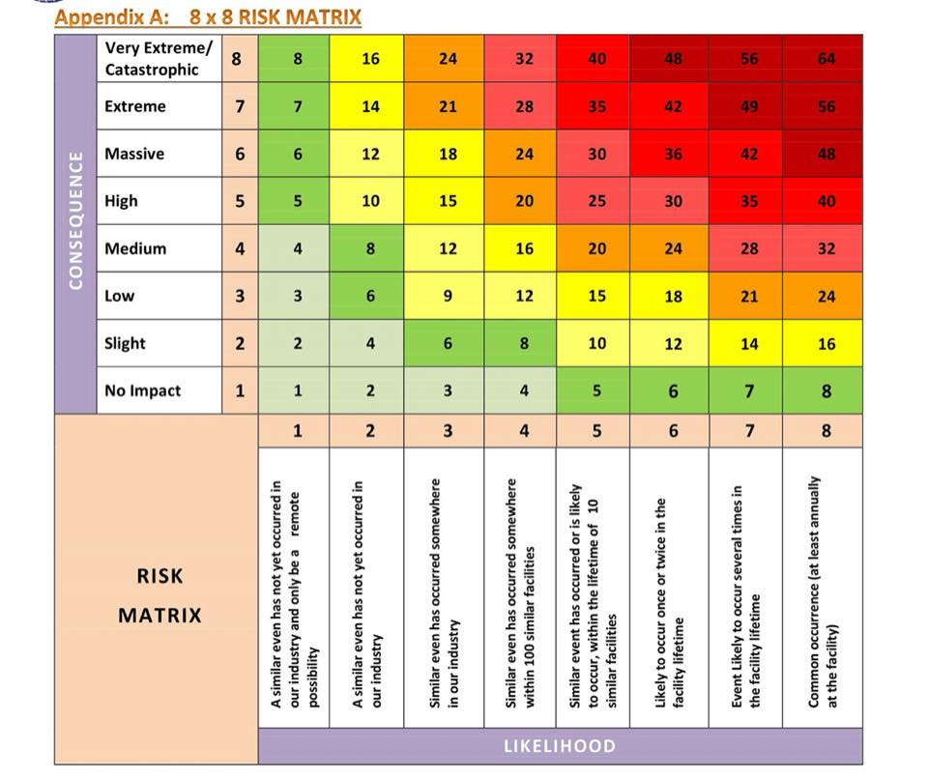

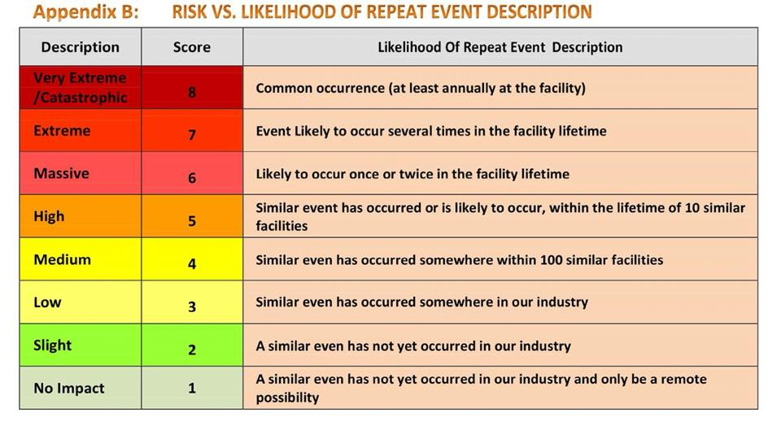

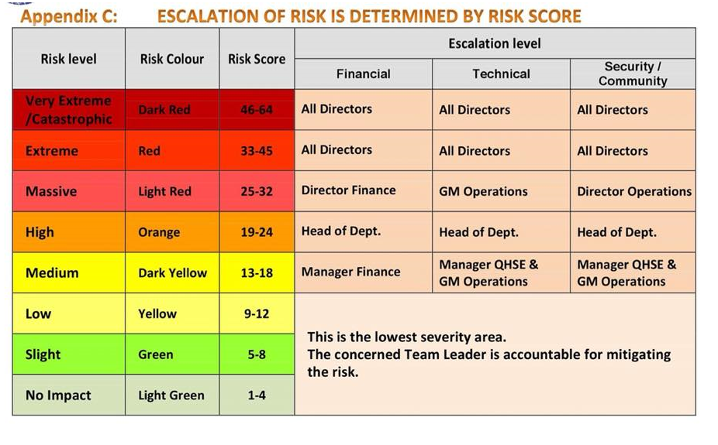

|  |  |  |  |  |
| --- | --- | --- | --- | --- |
| No. | Name of Risk | Likelihood | Consequences | Risk  Score |
| 1 | Project team member(s) will not be in place when required. | 2 | 6 | 12 |
| 2 | Risks associated with any conversions of existing data required before implementation of a new system. | 1 | 5 | 5 |
| 3 | Risks with the hardware and software (the development platform) chosen to perform project development. e.g., can this hardware and software handle the workload required to complete the project? | 1 | 4 | 4 |
| 4 | Risk to the project resulting from a mandated/mandatory completion date for the project. | 4 | 6 | 24 |
| 5 | The development team is unfamiliar with the environment being used (e.g., is the technology unfamiliar, has the team done this type of work before?). | 7 | 8 | 56 |
| 6 | Organisation and management | 3 | 5 | 15 |
| 7 | Natural Disaster or Pandemic | 7 | 2 | 14 |

s